MY VISIT to the HISTORY and CULTURE of CHINESE PERIPHERY
Shinichi Arai

Visiting Xinjiang Uighr Autonomous Region
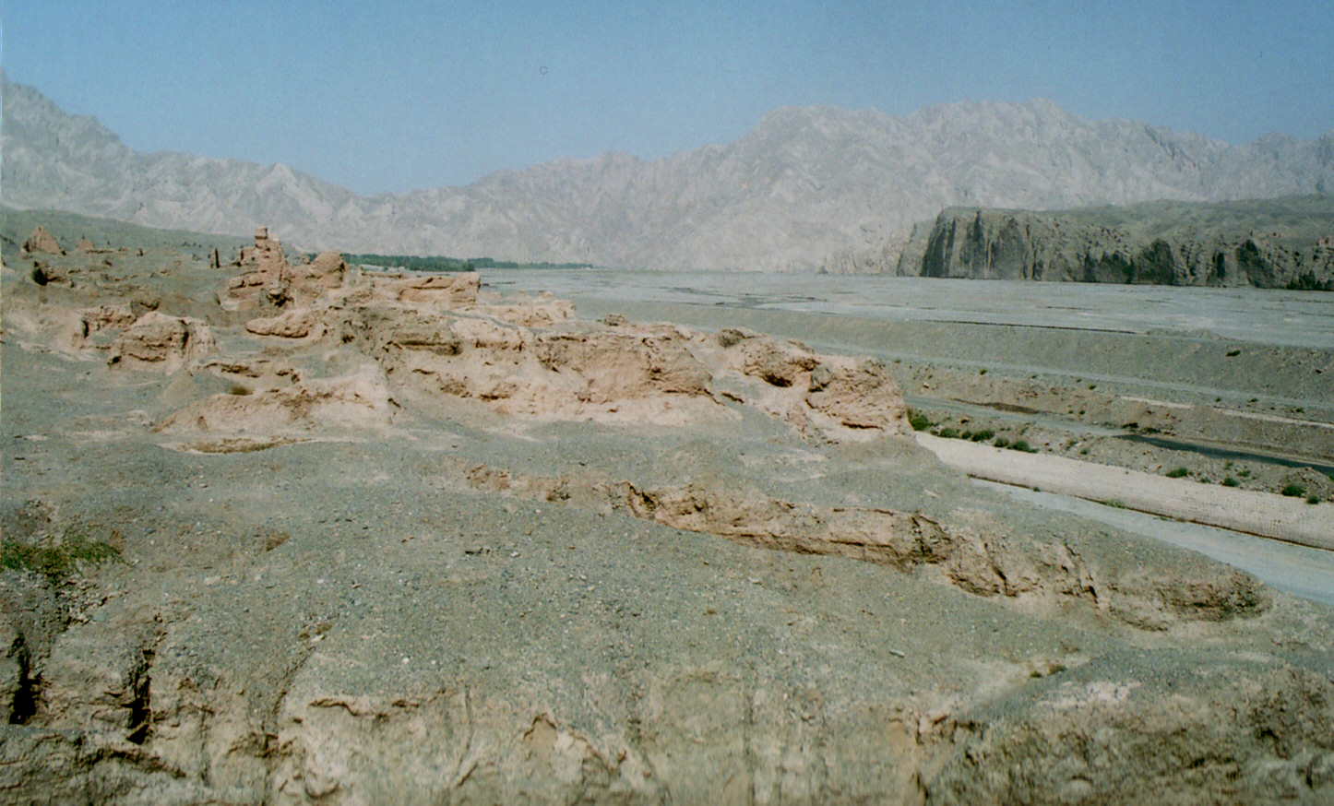
Xinjiang Uighr Autonomous Region is a large Province（Region) which covers one-six of Chinese Peoples Republic(CPR) and one of the districts in which many nationalities live since the ancient time. Now 60% of the population―about 16million are Uighr of Turkish origin and they declared twice their independence in 20century, 1934 and 1944, but they failed either to achieve it. The Region has longest frontier line in CPR with neighboring countries including many Islamic states of Central Asia, Afghanistan, Tajikhistan，Kazakhstan, Kyrghystan, Uzbekistan and Pakistan. The greater parts of Region’s population are Muslems and especially in the south its ethnic culture are rather Islamic than Chinese.
Recently exploitation of natural resources, mainly oil and natural gas in Takelamakan Desert and accompanying development of infrastructure has been progressed and the economy of the Region has developed rapidly. But on the other hand it has increased immigration from mainland and not only economic but also social gap between foreigners and native Uighr peoples are extending. Together with Tibet, Xinjiang had became still more difficult area for CPR to govern.
Northern part of the Region centering around Wlumuqi(metropolis) has been called as North Jiang while we call southern part as South Jiang. Through South Jiang and especially a part of it, Pamir plateau(Roof of the World) we can visit directly Afghanistan or Pakistan. But compared with the North, economic development of the South has delayed and immigration from mainland are limited. The South Jiang Railway which traverse the area had constructed only recently. The South has still retained Muslem culture more strongly.
I visited the South in September,2006. I aimed to study Buddhist ruins and relics which flourished about 6-9century.
My another aim were to make general survey of the Islamic world in CPR.

Front of Chinese Buddhism―Kuche and Kyzil Buddhist caves
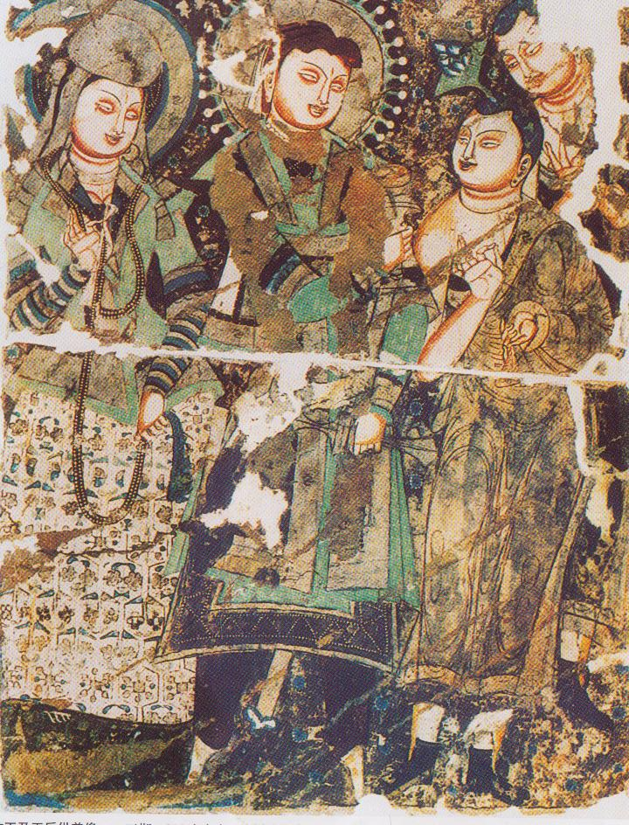
Buddhism of India had introduced to China first via oasis kingdoms of South Jiang. This part of Silk Road was called Tienshan South passage. One of the big oasis kingdoms of this rout which flourished after East Han period was Kuche (Kuča).The people speaked Tocharian, one of languages used around Central Asia and their spiritual life was highly influenced by Buddhism of India. In 5th century a monk Kumarajiva(344-413), one of the royal family of Kuche, had invited to China as a ‘state master’and there he laid foundation for Chinese Buddhism by translating about 380 original scriptures of Indian Buddhism into Chinese .
Kuche was conquered by Tang Dynasty in 7th sentury. Tang moved here its Military Administration for Natives of West and stationed garrison at important oasis cities in order to control market and distribution around the East Turkistan.
Under the rule of Tang(618-907) Kuche flourished again as a front for Chinese monks to absorb the Buddhism of India .When a famous Chinese monk Xuan-zan(602-664) visited here in 628,the King with many retainers greeted him at the gate of his castle and a few thousand monks welcomed him playing their musical instruments. Many of them gathered to the temples of Kuche to study the latest doctrines and writings of Buddhism. The ruin of Subhasi Temple as well as the cave temples at Kyzil, Kumtra and Simsim are well known today.
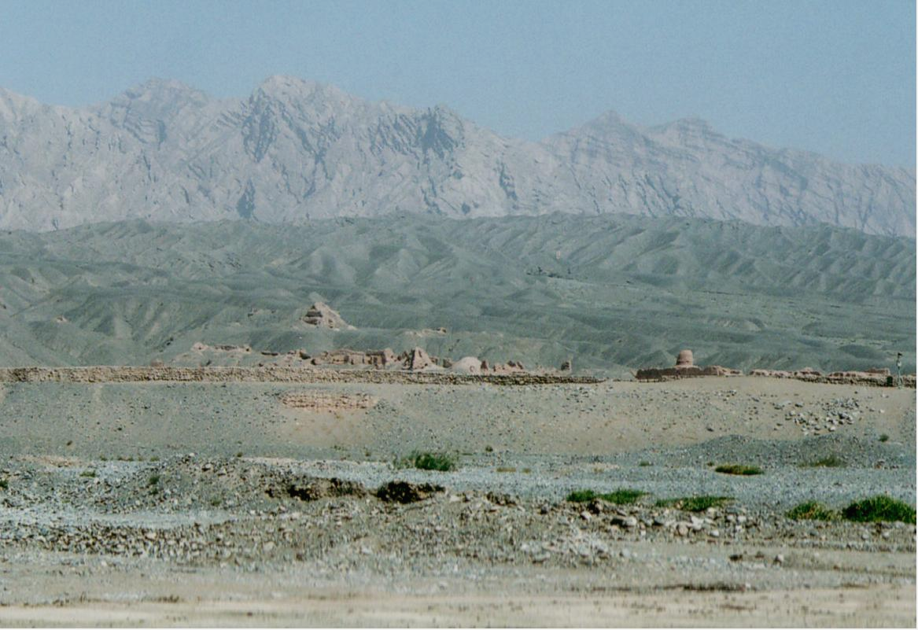
In September,2006 I visited the ruin of Subasi temple. The ruin situated at the south foot of Tienshan mountains and extended from east to west at both side of the river. Compared with east temple more architechtual ruins remained in the west. We can still recognize the places of towers, surmon hall and dormitory for monks. At the basement of central tower a mother with baby was buried, but we can not know exactly who she was. She might be a rich donor of the temple.
Many caves scattered at the neighborhood of Kuche. Most prominent group are Kyzil Thousand Buddhist Caves, one of four largest Buddhist cave of China. Total number of caves exceed 230, almost all of the cave were excavated at 4th－8th century and structure of caves or style of wall paintings they house were influenced much by Indian or Iranian style.
The motif of those wall paintings are almost related to the tales of Buddha’s previous lives, scenes from the Buddha`s life and legend and Buddha’s tales.
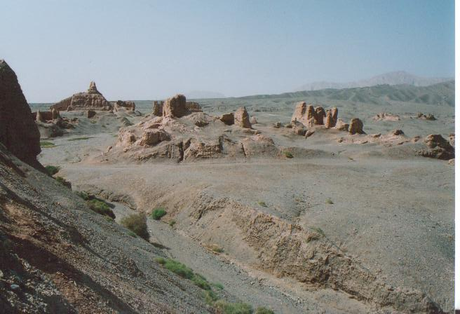
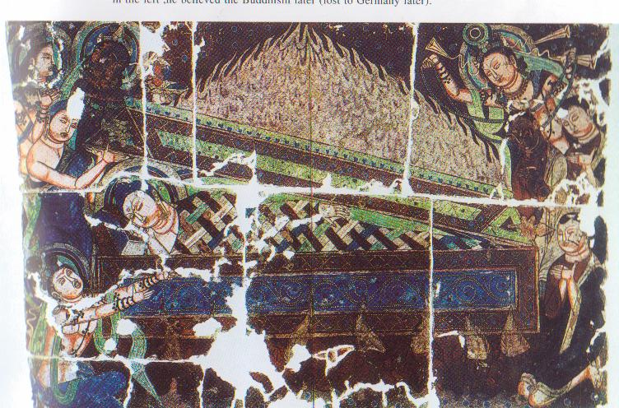
Among the wall paintings I strongly impressed by some paintings related to the death of Buddha, especially depicting 8 followers distributing Buddha’s ashes each other after cremation. Immediately before his death Buddha left his last words.゛Every human being cannot escape death. Notwithstanding my funeral you must continue your ascetic life. You could cut off your attachment and get the tranquility of mind by it”.The paintings represent the resolution of 8 followers to aim at self-perfection as Buddhist by continuing rigid ascetic life.
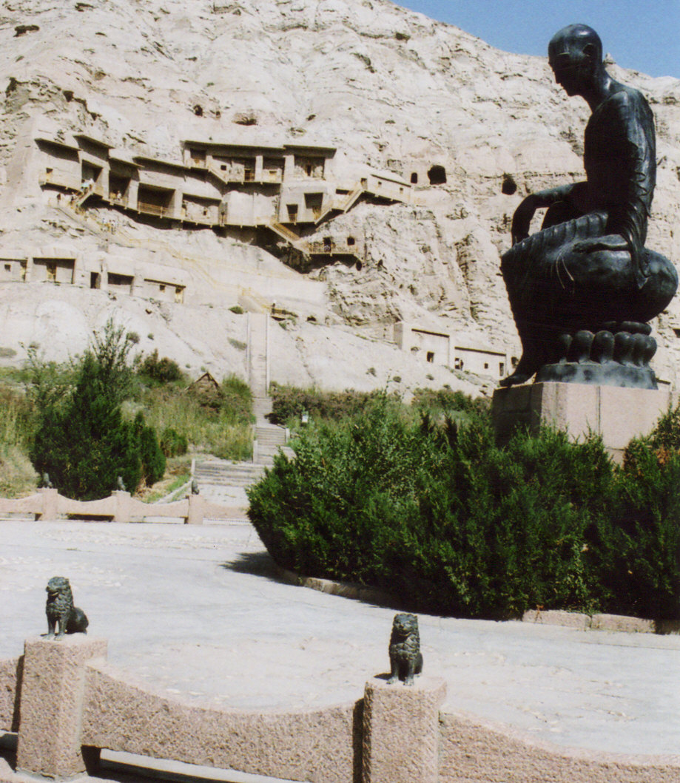
Although many scholars tended to think superiority of Mahayana(‘greater vehicle’＝salvation of mass) Buddhism in northern countries off India, these contents of wall paintings tell us strong influence of Hinayama(‘lesser vihicle’=self-perfection of individual Buddhist) Buddhism in this region.

At the entrance of the Kyzil Caves a bronze statue of Kumarajiva has erected(1994). He wanted to introduce here the Mahayana school, but as spreading the doctrine of this school the cave temples did decay gradually. From 8th to 9th century size of caves became smaller and wall paintings were often depicted over the old one. After the fall of Tang Dynasty(920) foreign people invaded here frequently and temples of Kuche was destroyed by fire. And in parallel with this process mass immigration and settlement of Uyghr to the south of Tienshan Mountains progressed. Then Xinjian became Uyghr and Muslem land.

Islam world in CPU―Kashgar

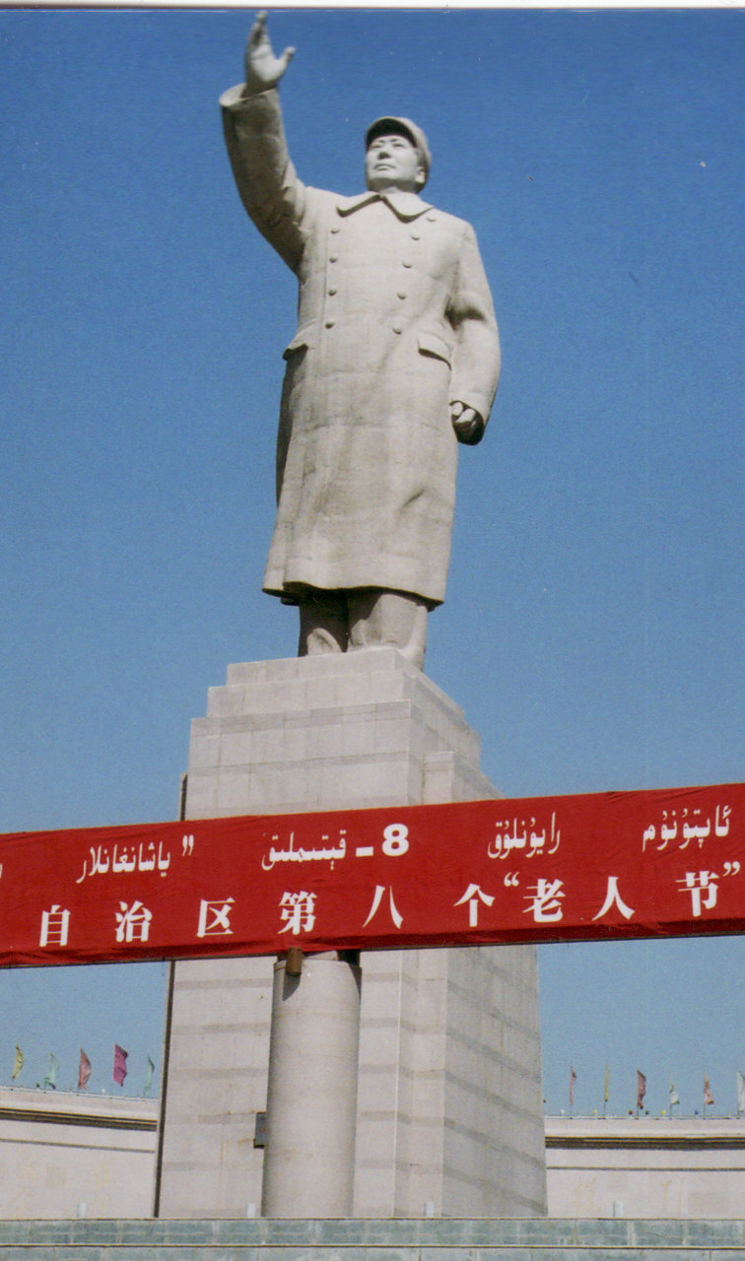
In 1999 for the first time South Jiang railway reached to Kashgar. It situated at the westmost frontier of China and was an important outfitting station on the old Silk Road. The population of this unique city is about 220thousand and 74% of them are Uyghr.
Kashgar is a largest market city in South Jiang. Tienshan South Passage met here with West Region South Passage which traverse narrow South corridor between Kunlun Mountains and Taklamakan Desert. Kashgar was not only a terminal city of Silk Road in China but also an entrance toward India or Central Asia because the city located at the north foot of Pamir Plateau, main rout of East－West traffic. Caravans from various places of Asia had came here to make a enormous profit from the East-West trade. Consequently bazaar and various kinds of handicraft had grown up greatly and still flourish as if they were in the fairy town of the Arabian Nights.

Kashgar is also Cnina’s Muslim center. We can find 30 mosques in the Old Town. Their central is the Idgah Mosque in which 40thousand Muslim worshipers could pray every Friday. Next to the Mosque big Bazaar bustles for day and night, some women covered in Muslim headdress even though others favor colorful fashions.
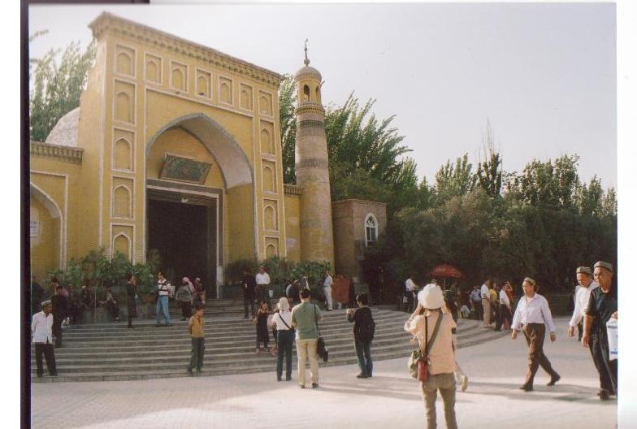
An American reporter wrote in 2003．“Above the square[before the Mosque],a large clock tower keeps the time. Herein lies another of Kashgar’s contradictions. The time is never right, nor can be. The enormous distance from Beijing means that Kashgar should be two to three time zones behind the capital. However, national law keeps all crocks ticking to the same hour. For several thousand years, though, Kashgar has made its own rules, and time is no exception. Locals simply set clocks back two hours.”(Ron Gluckman, , Kashgar’s Brilliant bazaar).
‘Contradiction’is the key word for understanding relation between CPR’s policy and Uyghr-Muslim populace of Xinjiang. Many of them are apt to think the national ethnic policy as repressive to their faith. Last year, during the Beijing Olympic Game, a series of attack on police in Xinjiang occurred. Next September the Muslim fasting month of Ramadan began. Then a county government of the Region prohibited government officials, Communist party members, teachers and student from observing Ramadan, while warning that “any person who was caught forcing another to observe Ramadan” would be punished. In another areas, the crackdown also was extended to the Muslim religious practices of men growing beard and women covering their faces with veils(REUTER, September 11,2008)
To observe Ramadan is one of the fundamental religious obligations for Muslim. Another obligation, Worship that means praying toward Mecca 5 times a day is prohibited too for Muslim members of public facilitie make s. Pilgrimage to Mecca is too one of obligations, but it is not compulsory because it would cost much time and money. However, even though a Muslim who have time and money is not always to be able to get official support for pilgrimage to Mecca because Chinese government adopts a quota system for the pilgrimage.
Every local government is allotted a fixed numbers of pilgrims qualified with official support including necessary visa and use of government prepared airplane for Mecca. Allocated number is very scarce, for Kashgar maybe 30-40 a year. Though they are rich or powerful, qualified pilgrims could made pilgrimage with relatively lower cost(about 20-30 Yuan).But other common pilgrims must privately go to the neighboring Muslim countries first to get visa and from there fly to Mecca, it costs about 40-50 Yuan.
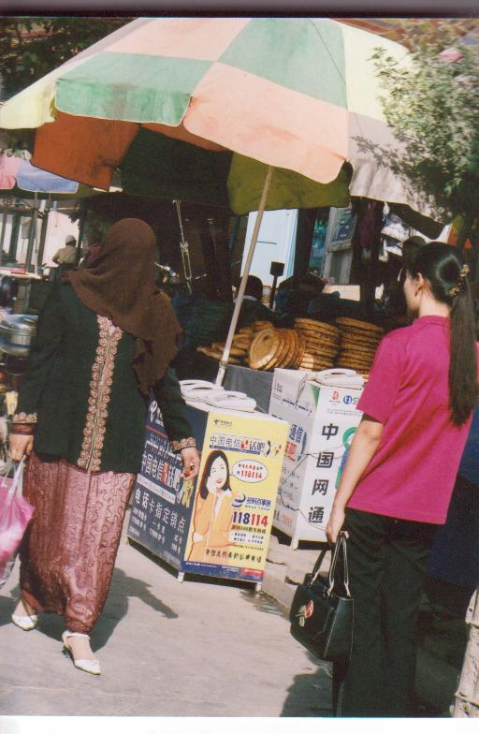
Of course there are many problems in the Muslim society of Uighr, e.g. inferior status of women ,and contradiction between national policy aiming prompt economic development and Muslim’s maintenance of severe Islamic discipline as a symbol of their ethnic identity may be inevitable. But it is not advisable to solve this delicate problem with one sided view or by military or police forces. From the Muslim’s view it will looks like oppressive and may cause further unrest in this Region.

